API Testing
- Manual testing of API done using Postman tool.
- Automation testing of API is done using Rest assured.
What is Client and Server?
Client:
- A client is a computer hardware device or software that accesses a service made available by a server.
- A server is often (but not always) located on a separate physical computer.
- From where we are trying to access the application is called client.
- A client is hardware or software that requests services from a server.
- Examples:
  - Web browsers (Chrome, Edge, Firefox) access websites.
  - Mobile app connecting to a backend system.
  - Email client (Outlook, Thunderbird) retrieving mail from a mail server.
- Key Point: The client initiates communication and depends on the server to provide resources or services.
Server:
- A server is physical computer dedicated to running services to serve the needs of other computers.
- Depending on the service that is running, it could be a file server, database server, home media server, print server, web server.
- A server is a computer (or software running on one) that provides services to clients.
- Types of Servers:
  - Web server → Hosts websites (e.g., Apache, Nginx).
  - Database server → Stores and manages data (e.g., MySQL, PostgreSQL).
  - File server → Provides shared file storage.
  - Print server → Manages printers in a network.
  - Media server → Streams audio/video content.
- Key Point: The server responds to requests, often serving multiple clients simultaneously.
Example: Visiting Google
- URL: google.com → The address of the resource you want.
- Client: Your browser (e.g., Chrome).
- Server: Google’s web servers that process the request and send back the search page.
- Process:
  - You type google.com in the browser.
  - Browser (client) sends a request via HTTP/HTTPS.
  - Google’s server receives the request, processes it, and sends back the webpage.
  - Browser displays the result to you.
Between the client and the server, the crucial piece is the connection—and the internet is what makes that possible.
- The client (your browser, app, or device) is the one making the request.
- The server (Google’s computers, for example) is the one holding the information or service you want.
- The internet acts as the bridge, carrying your request to the server and then delivering the server’s response back to you.
Here’s a simple way to visualize it:
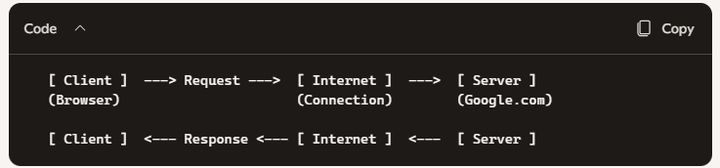
So, when you type google.com:
- Your browser (client) sends a request.
- The request travels through the internet connection.
- Google server processes it and sends back the search page.
- Your browser displays the result.
It’s a continuous back-and-forth conversation but always initiated by the client, esult are coming from server.

Client/Server Architecture
- 1-Tire Architecture
- 2-Tire Architecture
- 3-Tire Architecture
The “tier” refers to how responsibilities (like user interface, business logic, and data storage) are distributed between client and server systems.
1-Tire Architecture
- Definition: Everything (UI, logic, and data) is handled on a single system.
- Example: A standalone desktop application like Microsoft Excel or a simple offline game.
- Pros: Simple, fast, no network dependency.
- Cons: Limited scalability, no centralized data sharing.
2-Tire Architecture
- Definition: Splits into two layers — client and server.
- Client: Handles the user interface and sometimes part of the business logic.
- Server: Manages the database or backend services.
- Example: A client application (like a banking app) directly connected to a database server.
- Pros: Easier to manage than 1-tier, supports multiple clients.
- Cons: Tight coupling between client and server, harder to scale for large systems.
3-Tire Architecture
- Definition: Adds a middle layer (application server) between client and database server.
  - Client (Presentation Layer): User interface.
  - Application Server (Business Logic Layer): Processes requests, enforces rules.
  - Database Server (Data Layer): Stores and manages data.
- Example: Web applications like Amazon or Google — browser (client), web server (application logic), database server (storage).
- Pros: Better scalability, security, and maintainability.
- Cons: More complex setup and management.
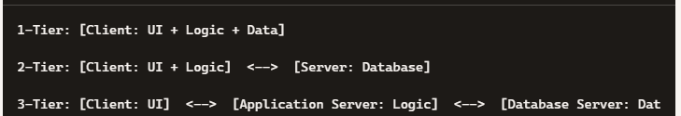
1-Tier vs 2-Tier Management
1-Tier Architecture
- Everything (UI, business logic, and data) is bundled into a single application.
- Example: A standalone desktop app where the program and its database are stored locally.
- Management Challenge:
  - If you need to update the logic or fix a bug, you must update the entire application on every client machine.
  - Data is scattered across multiple clients, making consistency and backup harder.
  - Scaling to multiple users is inefficient because each user has their own copy.
2-Tier Architecture
- Splits responsibilities into client and server:
  - Client → Handles user interface and sometimes part of the logic.
  - Server → Centralized database or backend service.
- Why Easier to Manage:
  - Centralized Data: All information is stored on the server, so backups, security, and consistency are easier.
  - Simplified Updates: If you change the database schema or logic, you only update the server, not every client.
  - Multi-client Support: Many clients can connect to the same server, reducing duplication.
  - Access Control: Permissions and authentication can be managed centrally on the server.
Example
- 1-Tier: Imagine a small shop where each cashier has their own Excel file for sales. If you want to change the format, you must update every file individually.
- 2-Tier: Instead, all cashiers use a client app that connects to a central database server. Update the server once, and all clients benefit immediately.
Presentation Layer
- What it is: The user interface (UI) - where the client interacts with the system.
- Responsibilities:
  - Displaying information to the user.
  - Collecting input (forms, clicks, searches).
- Examples:
  - Web browser pages (HTML, CSS, JavaScript).
  - Mobile app screens.
  - Desktop application UI.
Application Layer (Business Logic Layer)
- What it is: The middle layer that processes requests and enforces rules.
- Responsibilities:
  - Validating user input.
  - Applying business rules (e.g., calculating discounts, verifying login).
  - Coordinating between presentation and data layers.
- Examples:
  - Web servers (Apache, Nginx).
  - Application frameworks (java, python, c#, Spring Boot, .NET, Django,).
  - APIs that handle requests.
Data Layer
- What it is: The backend storage system where data is kept and managed.
- Responsibilities:
  - Storing, retrieving, and updating data.
  - Ensuring data integrity and security.
- Examples:
  - Databases (MySQL, PostgreSQL, Oracle).
  - File storage systems.
  - Cloud storage services.
What is an API?
- API stands for Application Programming Interface.
- The API is the bridge that ensures smooth communication between the client and the server.
- It is a set of rules and protocols that allows one application (or layer) to communicate with another.
- API is a way of communicating between two applications
- API is a way of communicating between two layers.
- APIs are the bridges that make communication possible — whether between two applications or between layers in an architecture. They standardize how requests and responses are exchanged, ensuring everything works smoothly together.
Think of it as a messenger: the client asks for something through the API, and the server responds with the requested data or action.
API as Communication
- Between Applications: For example, a weather app uses an API to fetch live weather data from a weather service.
Between Layers: In a 3-tier architecture:
- The Presentation Layer (UI) talks to the Application Layer through an API.
- The Application Layer talks to the Data Layer through another API (like SQL queries or ORM frameworks).
It is the responsibility of API layer to take the data from the front end and insert into the backend and fetch the data from the backend and display on the front end.
Examples of APIs
- Web APIs: REST, GraphQL, SOAP — used by web and mobile apps to fetch data from servers.
- Operating System APIs: Windows API, POSIX — allow applications to interact with the OS.
- Library APIs: Functions provided by programming libraries (e.g., TensorFlow API for machine learning).
How it works:
- Client sends a request (e.g., “Get user profile”).
- The API acts as the messenger, translating and forwarding the request to the server.
- The Server processes the request (fetches data, applies rules).
- The API sends the response back to the client in a standardized format (often JSON or XML).
- The Client displays the result to the user.
Why do we do API testing?
API testing is critical because APIs are the backbone of modern applications. Without it, even small issues can ripple across multiple systems, causing failures or security risks
When we do the testing of web applications we test the UI. On the UI result are coming from the API so instead of testing the UI we test the API to save the cost and improve efficiency.
- The UI is just a presentation layer - it shows results that come from the API.
- By testing the API directly, you validate the business logic and data flow without relying on the UI.
- This ensures that if the API is correct, the UI will display correct results too.
Faster and Cheaper
- UI tests often require complex setups (browsers, automation tools, rendering).
- API tests are lightweight: they send requests and check responses.
- Less overhead → faster execution → reduced testing costs.
Early Detection of Issues
- Bugs in APIs can be caught before they even reach the UI.
- This prevents cascading failures and saves time in debugging.
Better Coverage
- APIs expose multiple endpoints and scenarios that may not be visible through the UI.
- Testing APIs ensures deeper coverage of functionality.
API testing targets the engine of the application, not just the dashboard. That’s why it’s more efficient, cost-effective, and reliable than relying solely on UI testing.
Note: We should rely completely on API testing and not completely rely on UI testing. If we do API testing, we must spend very little time on UI testing. Like 20% time.
Type Of API
There are two types of API’s,
Simple Object Access Protocol(SOAP) This is very old way of API testing very a smaller number of companies follow this method. Thid Uses XML to display data. Soap supports only XML type of data
REST (Representational State Transfer) Latest Technologies It support different type of data xml , JSON, HTML, Text format
SOAP (Simple Object Access Protocol)
- Age: Older technology, introduced in the late 1990s.
- Data Format: Uses XML only for requests and responses.
- Protocol: Strictly defined, relies on WSDL (Web Services Description Language) to describe services.
- Features:
  - Strong standards for security (WS-Security).
  - Built-in error handling.
  - Highly structured but heavyweight.
- Drawbacks:
  - Verbose (XML messages are large).
  - Slower compared to modern alternatives.
  - Less flexible — only supports XML.
REST (Representational State Transfer)
- Age: Introduced in the early 2000s, now the most widely used.
- Data Formats: Supports multiple formats — JSON (most common), XML, HTML, plain text.
- Protocol: Uses standard HTTP methods (GET, POST, PUT, DELETE).
- Features:
  - Lightweight and faster.
  - Easy to use with web browsers and mobile apps.
  - Scales well for modern applications.
- Drawbacks:
  - Less strict standards compared to SOAP (security must be implemented separately).
  - Can be inconsistent if not well-designed.
SOAP = older, strict, XML-only, still used in some legacy enterprise systems.
REST = modern, flexible, lightweight, supports multiple formats, widely adapted on web and mobile apps.
NOTE: Both are Webservices

What is Webservices?
A web service is essentially a way for two applications to communicate with each other over the internet using standardized protocols. It acts like a bridge that allows different systems - even if they’re built in different programming languages or run on different platforms - to exchange data smoothly.
Definition: A web service is a software module available over the internet that uses open standards (like HTTP, XML, JSON) to enable communication between applications.
Platform Independence: Because web services use standard formats (XML, JSON), applications written in Java, Python, .NET, or any other language can interact with each other
Communication: Typically uses HTTP as the transport protocol, with data encoded in XML or JSON
Example
- A weather app on your phone calls a web service hosted by a weather provider.
- The web service processes the request and sends back data (temperature, forecast) in JSON or XML.
REST APIs are not SOAP-style web services, but they are web services in the broader sense because they provide services over the web using HTTP.

API vs Webservices
- Web service is an API wrapped in HTTP.
- All web services are APIs, but not all APIs are web services.
- A webservices needs a network for its operation while API doesn’t need any network for its operation.
When APIs Become Web Services
- An API becomes a web service when it is deployed in a web or production environment and made accessible over the internet for external or public use.
- local APIs are just interfaces within a system, but once you expose them over the web (HTTP/HTTPS) for external access, they are considered web services
- An API becomes a web service when it is exposed over the web (HTTP/HTTPS) for external or public use.

Example:
- A local API in your code → not a web service.
- The same API deployed on a server and accessible via https://api.example.com → now it’s a web service.

Rest API
Rest API method/ HTTP Method
- Get Retrieve data (Read).
- Post Create new data (Create).
- Put Update Existing Data (Update).
- Patch Update part of a resource (partial modification).
- Delete Remove data (Delete).
Each resource is identified by a URI (Uniform Resource Identifier).
REST APIs follow six guiding constraints:
- Client-Server Architecture → Separation of concerns between client (UI) and server (data/logic).
- Statelessness → Each request contains all necessary information; server does not store client state.
- Cacheable → Responses can be cached to improve performance.
- Uniform Interface → Standardized way to access resources (URIs, HTTP methods).
- Layered System → APIs can be structured in layers (security, load balancers, etc.).
- Code on Demand (optional) → Servers can send executable code (like JavaScript) to clients.
REST APIs support multiple formats:
- JSON (most common, lightweight).
- XML.
- HTML.
- Plain text.
Note: JSON is preferred today because it is easy to parse and widely supported
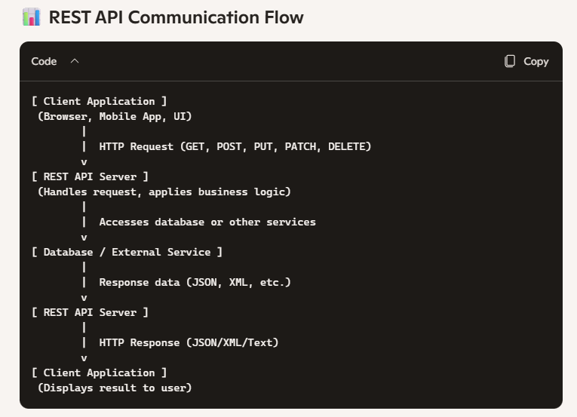
HTTP vs HTTPs
HTTP (Hyper Text Transfer Protocol)
- Definition: A protocol used for communication between web browsers and servers.
- Data Transfer: Sends data in plain text.
- Port: Default port is 80.
- Security: No encryption — vulnerable to interception (man-in-the-middle attacks).
- Speed: Slightly faster since there is no encryption overhead.
- Use Case: Suitable for non-sensitive content (e.g., public websites, blogs).
HTTPS (Hyper Text Transfer Protocol Secure)
- Definition: Secure version of HTTP, using SSL/TLS encryption.
- Data Transfer: Sends data in encrypted form (cipher text).
- Port: Default port is 443.
- Security: Provides authentication, integrity, and confidentiality.
- Speed: Slightly slower due to encryption, but modern hardware makes this negligible.
- Use Case: Essential for sensitive content (e.g., banking, e-commerce, login pages).
HTTP = simple, fast, but insecure.
HTTPS = secure, encrypted, and the modern standard for all websites.
Terminologies
- URI Uniform Resource identifier
- URL Uniform Resource Locator
- URN Uniform Resource Name
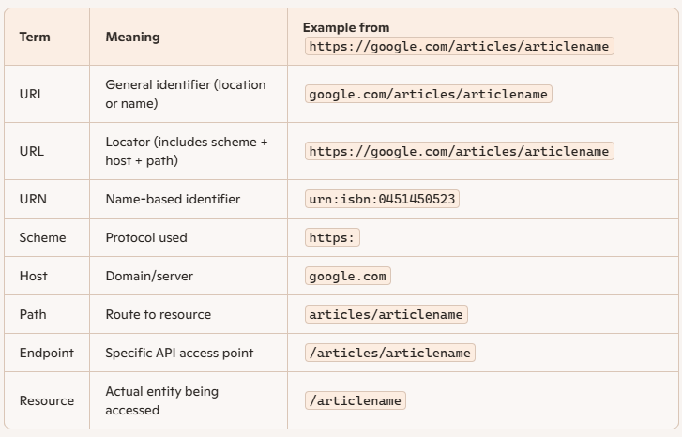
Breaking Down the Example
https://google.com/articles/articlename
- https: → Scheme (protocol used for communication).
- google.com → Host (domain name of the server).
- articles/articlename → Path (points to the specific resource).
- google.com/articles/articlename → URI (identifier of the resource).
- https://google.com/articles/articlename → URL (full locator including scheme).
- /articles/articlename → Endpoint (specific API endpoint).
- /articles → Path segment (collection of resources).
- /articlename → Resource (the actual entity being accessed).

Feature and Resource
Feature is the term used in manual testing to test some functionality and similar, resource is the term used in API automation testing referring some functionality.

Payload
payload refers to the actual data being sent in a request or returned in response. Think of it as the "body" of the message - the meaningful content, excluding headers, metadata, or transport details.
Payload means Body in the Http request and response message
- Request Payload
- Response Payload

Flight Booking Application Example
Request Payload
- This is the data you (the client) send to the server when making a booking request.
- Contains all necessary details for the booking.
- Example
  - "name": "John Doe",
  - "email": "john.doe@example.com",
  - "source": "Bengaluru",
  - "destination": "Delhi",
  - "date": "2026-03-10"
This is called the request payload because it carries the information needed by the server to process your booking.
Response Payload
- This is the data the server sends back to you after processing the request.
- Contains the result of the booking attempt (confirmation or failure).
- Example:
  - "bookingId": "FL12345",
  - "status": "Confirmed",
  - "message": "Your flight from Bengaluru to Delhi on 2026-03-10 has been booked successfully."
This is called the response payload because it carries the server’s reply to your request.
Request Payload → Data you send (name, email, source, destination, date).
Response Payload → Data you receive (confirmation, booking ID, status).
Payload = the actual data being exchanged in API communication.
- Request payload = what you send.
- Response payload = what you get back.

Postman
- Definition: Postman is a popular API testing tool used by developers and testers to interact with APIs.
- Primary Use: Initially designed for manual testing of APIs, allowing users to send requests (GET, POST, PUT, DELETE, etc.) and inspect responses.
- Ease of Use: Provides a user-friendly interface to test endpoints without writing code.
Postman started as a manual API testing tool.
Now it’s a full-fledged API platform used for testing, automation, collaboration, documentation, and monitoring.
Postman is available in both desktop and web versions, and thanks to account-based synchronization, any changes you make in one environment are automatically reflected in the other.
Key Feature
- Manual API Testing
  - Send requests with payloads, headers, and parameters.
  - Validate responses (status codes, JSON/XML data).
- Automation Support
  - Write test scripts in JavaScript.
  - Automate workflows using collections and environments.
- Collaboration
  - Share collections and environments with team members.
  - Useful for QA and development teams working together.
- Documentation
  - Recently, Postman introduced features to auto-generate API documentation from collections.
  - Developers now use it not only for testing but also for publishing and maintaining API docs.
- Mock Servers & Monitoring
  - Create mock APIs for testing before backend is ready.
  - Monitor APIs for uptime and performance.
🗂️ Workspace
- Definition: A workspace in Postman is like a project area where you organize all your API-related files.
- Purpose: Helps teams or individuals keep requests, collections, environments, and documentation grouped together.
- Capabilities:
  - Create a new workspace.
  - Rename an existing workspace.
  - Delete a workspace.
- Flexibility: Inside one workspace, you can create any number of collections.
📁 Collection
- Definition: A collection is like a folder inside a workspace.
- Purpose: Organizes related API requests together, we can create, delete, run the collection, rename the collection
- Contents:
  - Multiple folders (sub-grouping).
  - HTTP requests (GET, POST, PUT, PATCH, DELETE).
- Example:
  - Workspace: Flight Booking APIs
  - Collection: User Management
In short:
- Workspace = the big container (project area).
- Collection = folders inside the workspace holding requests.
- Requests = actual API calls you test.
API Communication Flow
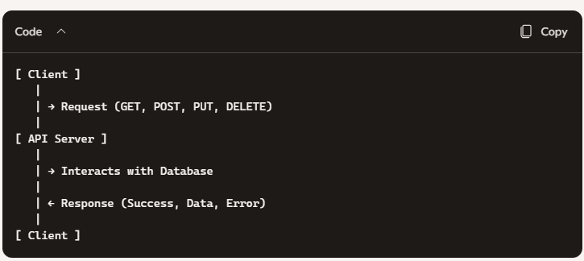

HTTP Methods and Their Purpose
Method | Action | Database Operation
GET | Retrieve data from server | Read from database
POST | Send new data to server | Creating new record
PUT | Replace existing data | Update entire record
PATCH | Modify part of existing data | Update partial record
DELETE | Remove data from server | Delete record

- You send a request using an HTTP method.
- The API processes it and interacts with the database.
- You receive a response with the result.

Sample API
URL: https://jsonplaceholder.typicode.com/posts?UserId=2
- Host Name → jsonplaceholder.typicode.com
  - This is the domain where the API is hosted.
- Path → /posts
  - This specifies the resource you’re accessing (in this case, posts).
- Query Parameters → ?UserId=2
  - This filters the resource. Here, it means: “Give me posts where UserId = 2.”
Part of URL | Meaning | Example
Scheme | Protocol used | https
Host | Domain name | jsonplaceholder.typicode.com
Path | Resource route | /posts
Query Parameter | Filter or condition | UserId=2
Example in Postman
- Method: GET
- URL: https://jsonplaceholder.typicode.com/posts?UserId=2
- Response: Returns all posts created by user with ID = 2.
one host (domain) can expose multiple paths to access different resources.
Example: jsonplaceholder.typicode.com
This host provides several paths for different resources:
- /posts → Access blog posts
- /comments → Access comments
- /albums → Access albums
- /photos → Access photos
- /todos → Access to-do items
- /users → Access user data
In short:
- Host = the server (like the house address).
- Path = the specific door you’re knocking on to access a resource.
- One host can have many paths, each pointing to a different resource.

GET
What all things we value as a tester when we test get method of API testing?
- We validate response status code
- How much time it take?
- How data we capture?
- Body of the response
- Content of the response
- Cookies parts
- Headers
- Test Result
GET method in API testing, a tester values several aspects to ensure the API behaves correctly and meets expectations.
Key Validation Points for GET Method
A tester checks status, performance, correctness, structure, headers, cookies, and test results when validating a GET method.
- Response Status Code
  - Verify the API returns the correct HTTP status (e.g., 200 OK for success, 404 Not Found if resource doesn’t exist, 401 Unauthorized if access is restricted).
- Response Time
  - Measure how long the API takes to respond.
  - Helps assess performance and detect latency issues.
- Data Accuracy
  - Validate that the data retrieved matches what’s stored in the database.
  - Ensure filtering, sorting, and pagination work correctly.
- Response Body
  - Check the structure (JSON/XML format).
  - Validate required fields are present and data types are correct.
- Content Validation
  - Ensure the actual content is correct (e.g., user details, product info).
  - Confirm business rules are applied (e.g., only active users returned).
- Headers
  - Validate response headers (e.g., Content-Type: application/json, caching headers, authorization tokens).
  - Ensure security headers are present if required.
- Cookies
  - Check if cookies are set or updated correctly (important for session management).
- Test Results
  - Document pass/fail outcomes for each validation.
  - Include automated assertions in Postman or other tools to confirm expected behavior.

Difference Between the Two
- https://jsonplaceholder.typicode.com/users/1
  - Uses a path parameter (/1) to directly identify the user with ID = 1.
  - This is a RESTful style: the resource itself is represented by its unique identifier in the path.
  - Returns exactly one user (user with ID 1).
  - Postman Response Display:
    - You’ll see one JSON object in the response body.
- https://jsonplaceholder.typicode.com/users?id=2
  - Uses a query parameter (?id=2) to filter the list of users.
  - This is more like a search/filter style: you’re asking for users where the id equals 2.
  - Technically, it could return multiple results if more than one user matched the filter (though in this case, only one user will match).
  - Postman Response Display:
    - You’ll see an array (square brackets) containing one object.

Http Status Codes
- Level 200
  - 200 Ok
  - 201 Created
  - 202 Accepted
  - 203 Non-Authoritative Information
  - 204 No Content
- Level 400
  - 400 Bad Request
  - 401 Unauthorized
  - 404 Not Found
  - 405 Method Not Allowed
  - 409 Conflict
  - 429 Too Many Requests
- Level 500
  - 500 Internal Server Error
  - 501 Not Implements
  - 502 Bad Gateway
  - 503 Service unavailable
  - 504 Gateway Timeout
  - 599 Network Timeout
How to Create our Own API?
To Create our own API, we need to have some software:
- NodeJS node –v
- NPM (Node Package manager) (By default it will come with NodeJS software) npm -v
- Install JSON server npm install -g json-server to install json server

Create a json file and add json data into it
Open cmd
Navigate to that directory or location where yours json file is saved e.g students.json
In cmd type json-server students.json
It will give us aendpoints of local host

